**Daniel Meyer – Lab 2 Report**

**Lab2.asm**

;Name(s): Daniel Meyer

;Lab#2: Arithmetic Functions

;Description: This lab introduces basic arithmetic functions

; such as absolute value and subtraction. Subtraction

; is done by adding the 2's complement of the value to

; be subtracted as there is no subtract function in LC-3.

; Absolute value uses the Break function when the value

; is positive, and the 2's complement is used when

; the value is negative.

; The results are store in memory locations x3120

; thru x3125. There are 5 data sets for testings. These

; Data#.asm files should be loaded prior to Lab2.asm.

; Once both files are loaded results of each function are

; stored in x3122 thru x3125 with the data values for X

; and Y stored in x3120 and x3121 respectively.

.ORIG x3000

LDI R0, X ;

LDI R1, Y ;

;X - Y

NOT R3, R1 ;2's complement

ADD R3, R3, #1 ;-Y

ADD R3, R0, R3 ;X + (-Y)

STI R3, XSUBY ;Store result

;|X|

ADD R2, R0, #0 ;

BRzp abs1 ;Break if >=0

NOT R2, R2 ;2's complement

ADD R2, R2, #1 ;|X|

STI R2, absX ;Store result

abs1 STI R2, absX ;

;|Y|

ADD R3, R1, #0 ;

BRzp abs2 ;Break if >=0

NOT R3, R3 ;2's complement

ADD R3, R3, #1 ;|Y|

STI R3, absY ;Store result

abs2 STI R3, absY ;

;|X| - |Y|

NOT R4, R3 ;2's complement

ADD R4, R4, #1 ;-|Y|

ADD R4, R2, R4 ;|X| + (-|Y|)

BRz store ;if =0, Z = 0

BRp pos ;if >0, go to pos

;Negative

AND R4, R4, #0 ;clear R4

ADD R4, R4, #2 ;R4 = 2, Z = 2

BR store ;Break to store

;Positive

pos AND R4, R4, #0 ;clear R4

ADD R4, R4, #1 ;R4 = 1, Z = 1

store STI R4, Z ;Z = R4

HALT

X .FILL x3120

Y .FILL x3121

XSUBY .FILL x3122

absX .FILL x3123

absY .FILL x3124

Z .FILL x3125

.END

**Data1.asm**

;Class:CSE 313 Machine Organization Lab

;Section: 02

;Instructor: Taline Georgiou

;Term: Summer 2019

;Name(s): Daniel Meyer

;Lab#2: Arithmetic Functions

;Description: This file contains the first data set for Lab2.asm

.ORIG x3120

.FILL #9 ;x3120 = 9

.FILL #-13 ;x3121 = -13

.END

**Data2.asm**

;Class:CSE 313 Machine Organization Lab

;Section: 02

;Instructor: Taline Georgiou

;Term: Summer 2019

;Name(s): Daniel Meyer

;Lab#2: Arithmetic Functions

;Description: This file contains the second data set for Lab2.asm

.ORIG x3120

.FILL #10 ;x3120 = X

.FILL #20 ;x3121 = Y

.END

**Data3.asm**

;Class:CSE 313 Machine Organization Lab

;Section: 02

;Instructor: Taline Georgiou

;Term: Summer 2019

;Name(s): Daniel Meyer

;Lab#2: Arithmetic Functions

;Description: This file contains the third data set for Lab2.asm

.ORIG x3120

.FILL #-11 ;x3120 = X

.FILL #15 ;x3121 = Y

.END

**Data4.asm**

;Class:CSE 313 Machine Organization Lab

;Section: 02

;Instructor: Taline Georgiou

;Term: Summer 2019

;Name(s): Daniel Meyer

;Lab#2: Arithmetic Functions

;Description: This file contains the fourth data set for Lab2.asm

.ORIG x3120

.FILL #11 ;x3120 = X

.FILL #-15 ;x3121 = Y

.END

**Data5.asm**

;Class:CSE 313 Machine Organization Lab

;Section: 02

;Instructor: Taline Georgiou

;Term: Summer 2019

;Name(s): Daniel Meyer

;Lab#2: Arithmetic Functions

;Description: This file contains the fifth data set for Lab2.asm

.ORIG x3120

.FILL #12 ;x3120 = X

.FILL #12 ;x3121 = Y

.END

**Screenshots**

**Data 1 Results**

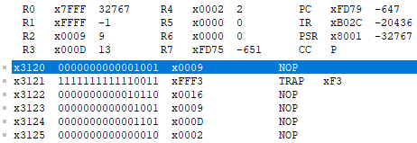

**Data 2 Results**

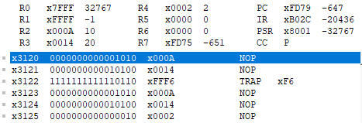

**Data 3 Results**

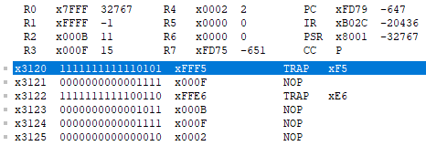

**Data 4 Results**

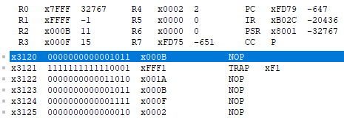

**Data 5 Results**

